First of all, I make lnsales variable that represent log of sales variable. Why I did that because log does not change as a rate and it is not effect to output however it makes variance so little therefore it makes so easy to calculate OLS.In a nutshell my dependent variable is log of sales.
Then I created variable which is called as large. In description of project there is we should split as large and small so I created large variable that show as small that smaller than median and large sales that bigger than median. In the variable of large ‘0’ represent small sales and “1” represent large sales.
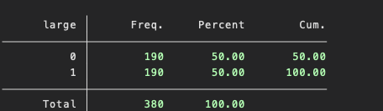
Then I did regression of lnsales for small sales. My variables: dependent is lnsales and other parametres are nfull, npart, hoursw, ssize.

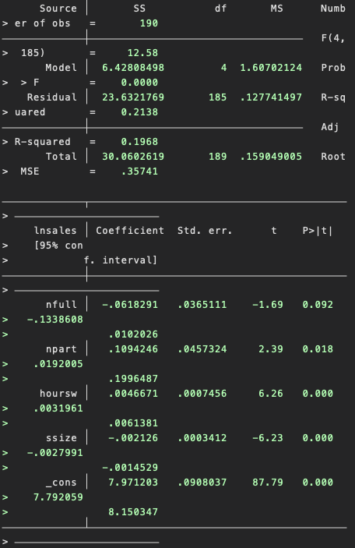
R^2 =0.20 → The model explains around 20% of the variation in log sales.
Signs and significance:
-nfull (full-time workers):Effect is negative and borderline significant at the 10% level.For small shops hiring more full-time workers tends to reduce sales possibly because additional permanent staff increases fixed costs without proportional gains in productivity.
-npart (part-time workers): Positive and statistically significant at 5%.Flexible part-time labour seems to help small shops adjust staff to peak hours and increase sales.
-hoursw (weekly opening hours):Strongly positive and highly significant.Longer opening hours give customers more opportunity to shop which clearly increases sales.
-ssize (store size): Negative and highly significant.Among small shops larger physical size is associated with lower sales. This suggests possible diseconomies of scale or inefficient use of space.

Overall, for small shops flexible part-time labour and longer opening hours increase sales while more full-time workers and larger store size tend to reduce sales.
LARGE SALES:
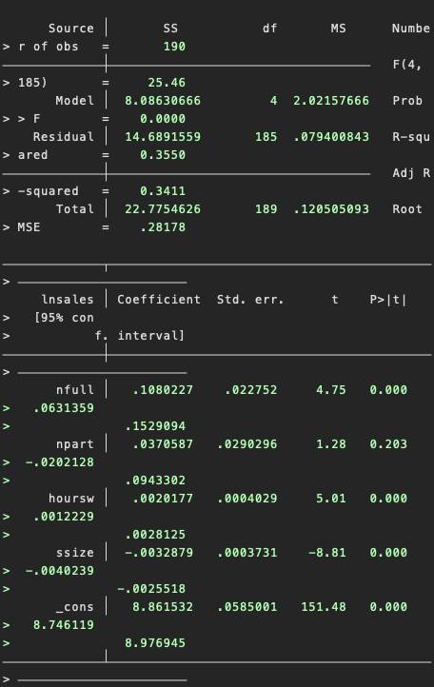
Signs and significance:
-nfull (full-time workers): Positive and highly significant.For large shops additional full-time employees significantly increase sales. Large stores seem to rely on stable full time staff to operate efficiently.
-npart (part-time workers): Positive but not statistically significant.Part time labour does not play a major role in explaining sales for large shops.
-hoursw (weekly opening hours): Strongly positive and significant similar to small shops.
-ssize (store size): Again negative and highly significant.Even for large shops an increase in physical size is associated with lower sales suggesting over-expansion or inefficient use of additional space.
COMPARE
Comparing the two groups full-time labour hurts small shops but helps large shops.Part time labour is crucial only for small shops. In both groups larger store size is associated with lower sales.

Single Hypothesis Tests
For each coefficient, the regression output reports a t-statistic and p-value for the null hypothesis:
Example (small shops, npart):t ≈ 2.39, p ≈ 0.018.Since p < 0.05, I reject H_0 and conclude that the number of part-time workers has a statistically significant positive effect on log sales in small shops.
JOINT HYPOTHESIS
I also perform joint tests to see whether groups of labour variables matter collectively.
-Small shops: nfull and npart jointly zero
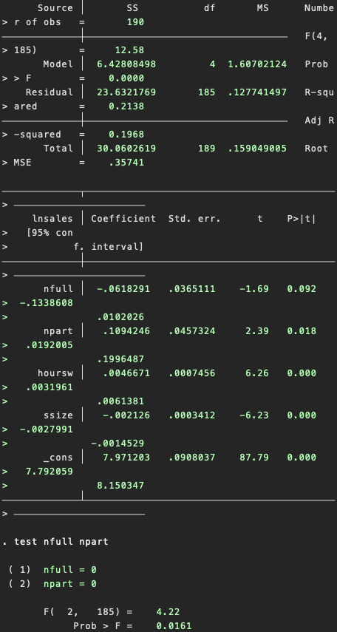
Since p ≈ 0.0161 < 0.05, I reject the null that nfull and npart are jointly zero. In small shops the numbers of full-time and part-time workers jointly have a statistically significant impact on sales even though nfull alone is only marginally significant.
All labour variables jointly zero
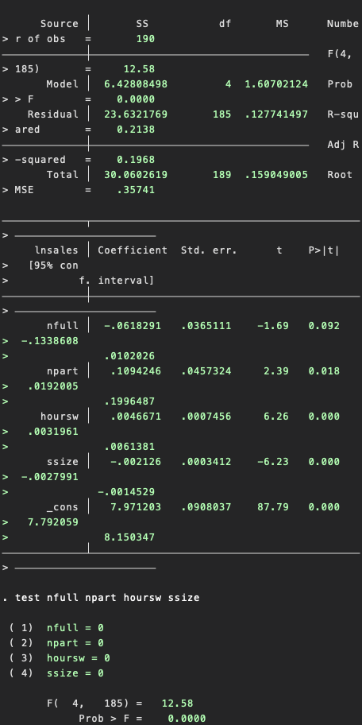
Labour variables as a group significantly explain variation in sales

JOINT TESTS FOR LARGE SALES

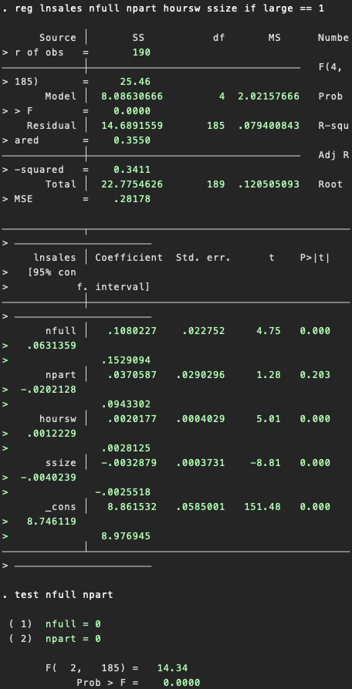
This result means that nfull and npart jointly have explanatory power for sales.Even though npart is not statistically significant on its own, the joint F-test shows that the two worker types together significantly contribute to explaining variation in sales.
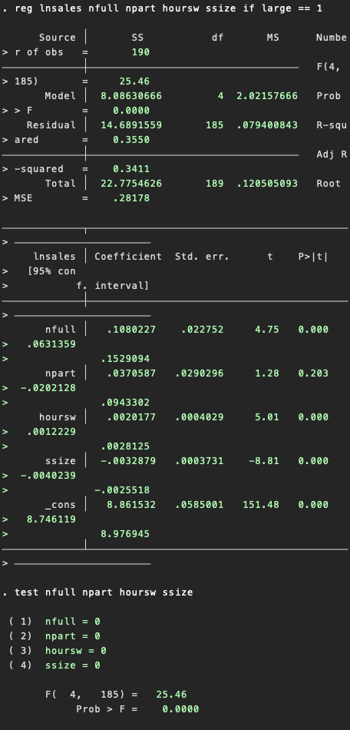
Since the p-value is 0.0000, we reject the null hypothesis at any significance level.This means that as a group, the variables: nfull, npart, hoursw and ssize jointly have a statistically significant effect on store sales for firms with large sales. In other words, for large stores the explanatory variables matter collectively and leaving them out would significantly worsen the model.
CONCLUSION:
This study examined the determinants of store performance by estimating log-sales regressions for small and large stores. The results show that inputs significantly affect sales levels. Single and joint hypothesis tests confirm that these variables are statistically relevant especially within large stores. Overall, the evidence indicates that workforce structure and store capacity are key drivers of sales performance across both groups.

